**NAME:** ALEENA SAEED

**PROGRAM:** BSCS

**COURSE TITLE:** Computer Architecture (LAB-7)

**SEMESTER:** 4

**SAP ID:** 56270

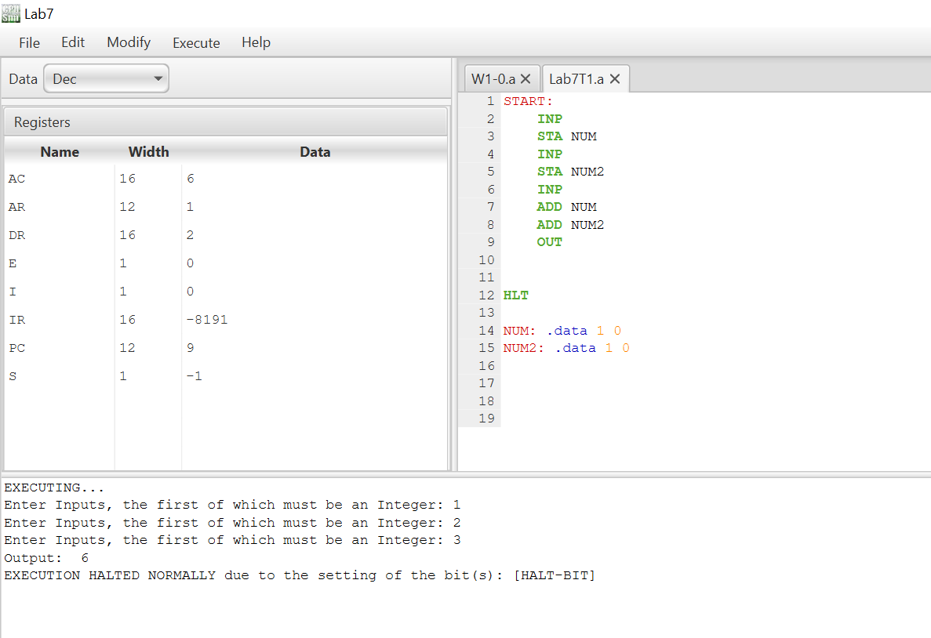**TASK-1:**

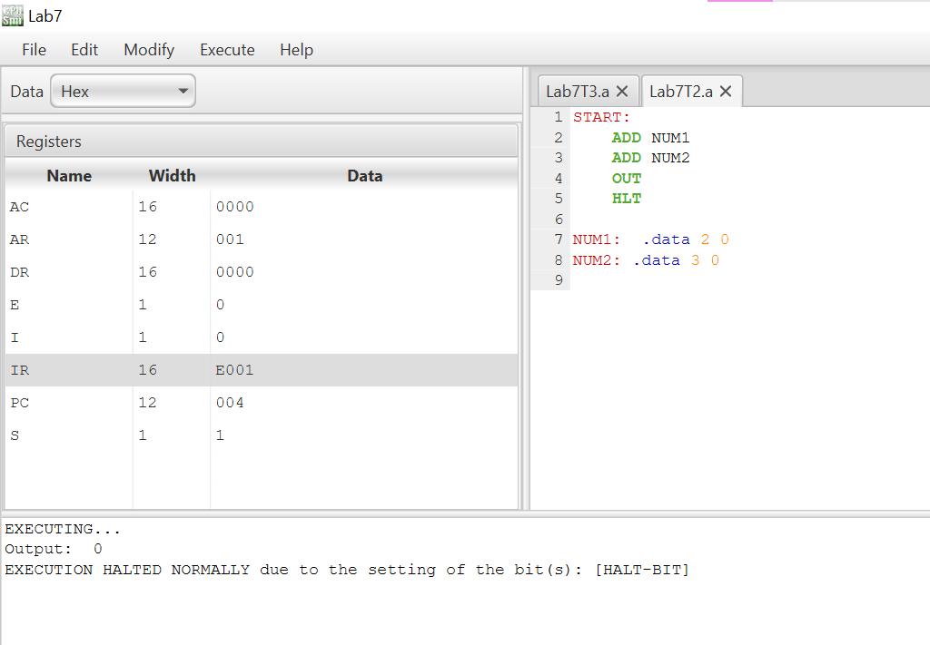**TASK-2:**

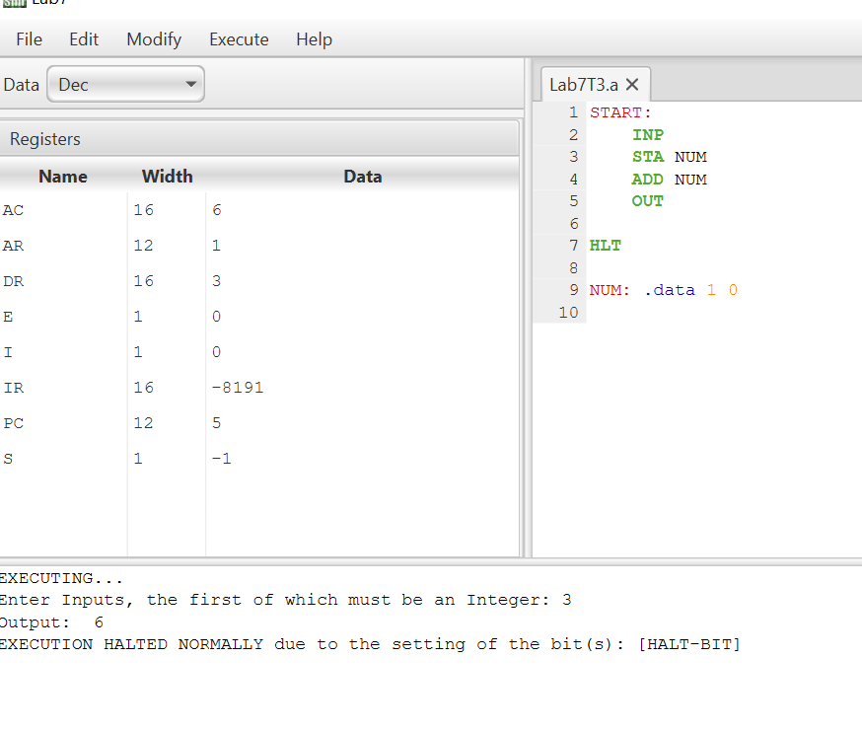**TASK-3:**